Date: 1st September, 2025

Program Title: 8-Puzzle Program

Name: Prakrithi Jain
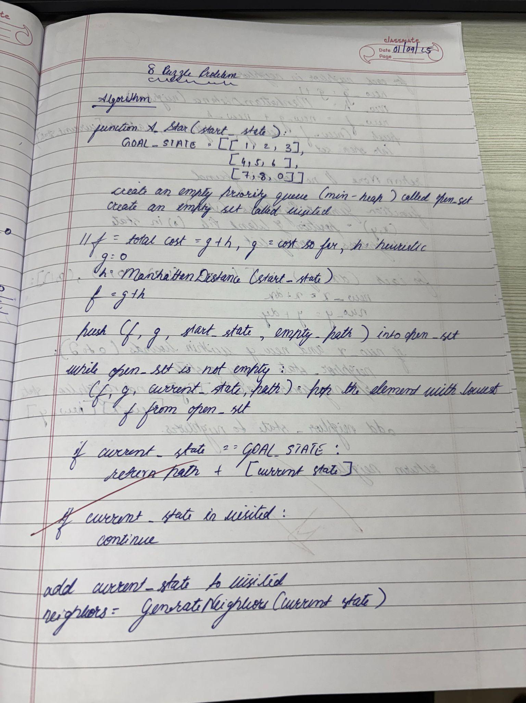

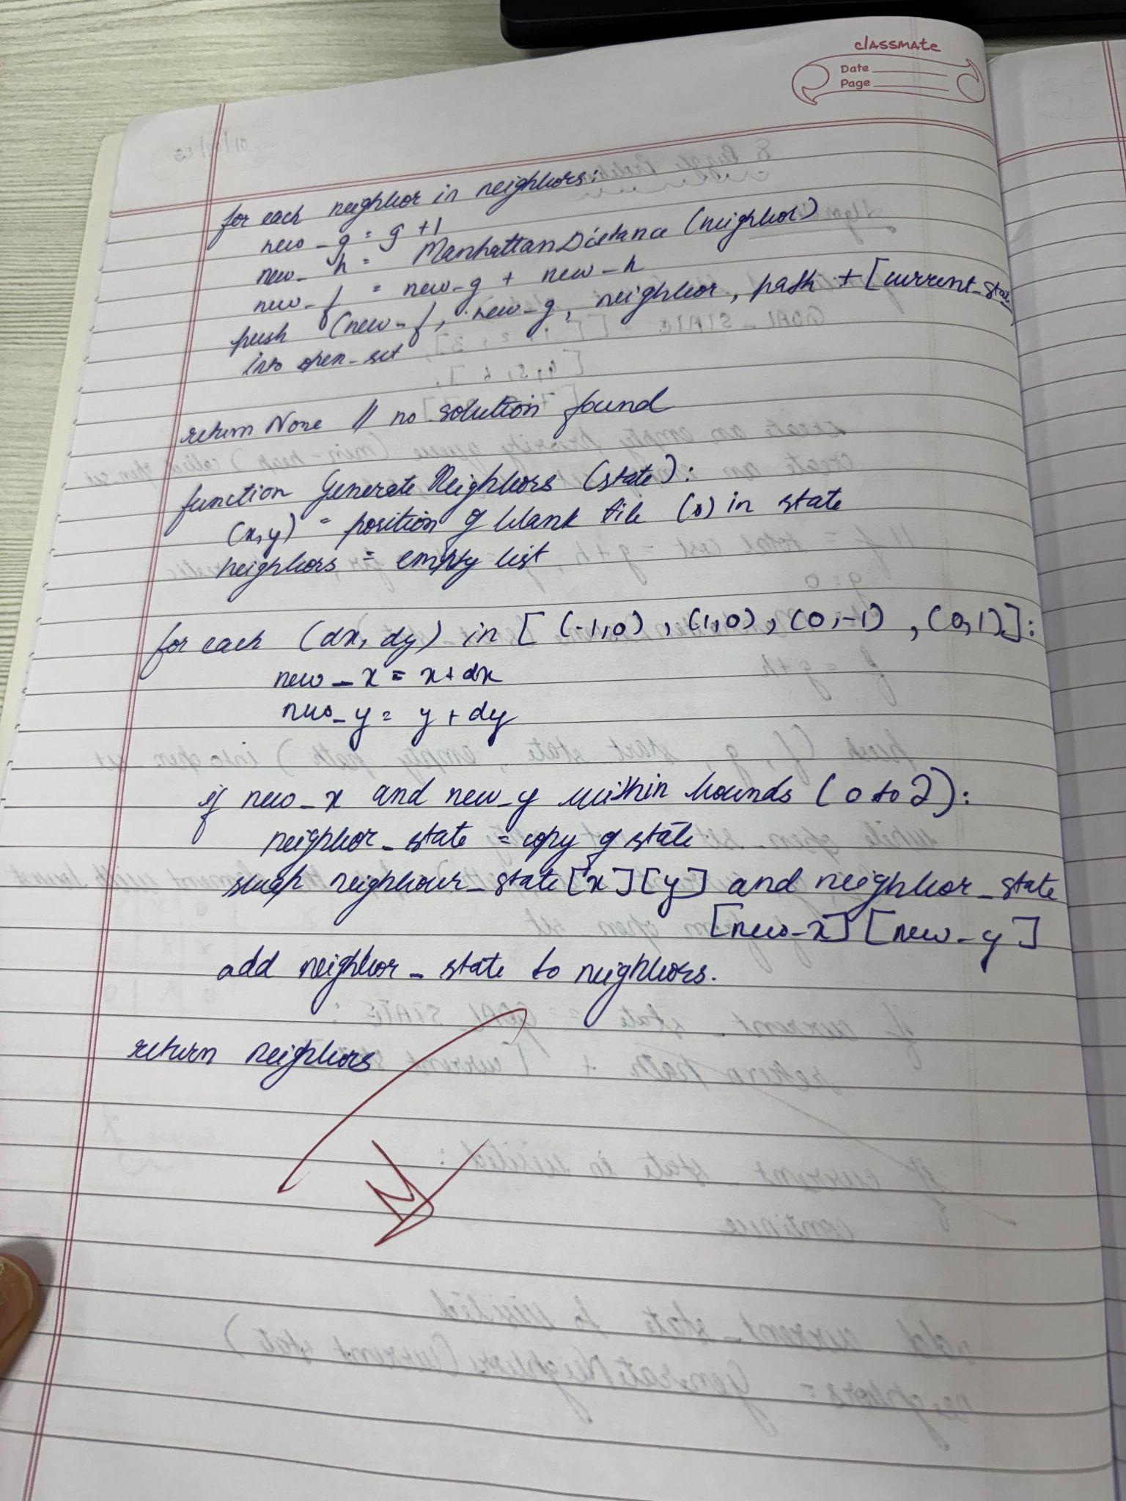

code:
import heapq

# Goal state
GOAL_STATE = [[1,2,3],[4,5,6],[7,8,0]]

# Helper to flatten 2D list
def flatten(state):
return [num for row in state for num in row]

# Manhattan Distance Heuristic
def manhattan(state):
distance = 0
for i in range(3):
for j in range(3):
val = state[i][j]
if val != 0:
goal_x, goal_y = divmod(val - 1, 3)
distance += abs(goal_x - i) + abs(goal_y - j)
return distance

# Find position of 0 (blank)
def find_blank(state):
for i in range(3):
for j in range(3):
if state[i][j] == 0:
return i, j

# Generate possible moves
def get_neighbors(state):
x, y = find_blank(state)
moves = []
directions = [(-1,0),(1,0),(0,-1),(0,1)] # up, down, left, right
for dx, dy in directions:
nx, ny = x + dx, y + dy
if 0 <= nx < 3 and 0 <= ny < 3:
new_state = [row[:] for row in state]
new_state[x][y], new_state[nx][ny] = new_state[nx][ny], new_state[x][y]
moves.append(new_state)
return moves

# A* Search
def a_star(start):
visited = set()
heap = []
heapq.heappush(heap, (manhattan(start), 0, start, [])) # (f, g, state, path)

while heap:
f, g, current, path = heapq.heappop(heap)
if current == GOAL_STATE:
return path + [current]

state_tuple = tuple(flatten(current))
if state_tuple in visited:
continue
visited.add(state_tuple)

for neighbor in get_neighbors(current):
heapq.heappush(heap, (g + 1 + manhattan(neighbor), g + 1, neighbor, path + [current]))

return None

# Example usage
start_state = [[1,2,3],[0,4,6],[7,5,8]]
solution = a_star(start_state)

# Print solution steps
if solution:
for step in solution:
for row in step:
print(row)
print("------")
else:
print("No solution found.")

Output:
